**NAMRIA Provident Fund**

**Information System**

##### **(NPFIS)**

**USER’S MANUAL**

*Systems Development and Programming Division*

*Information Management Department*



TABLE OF CONTENT

**PREFACE** 3

**INTRODUCTION** 4

**How to launch NPFIS** 4

**Using the application** 5

**How to use Loan Management** 5

**How to use New Loan** 8

**How to use Member’s Amortization Schedule Report** 9

**How to use Member’s Loan Summary Report** 11

**How to use List of Borrower’s for Salary Deduction Report** 12

**How to use Signatory Library** 14

**How to use Branch/Division Library** 15

How to Add a Branch 15

How to Edit a Branch 16

How to Delete a Branch 18

How to Add a Division 18

How to Delete a Division 19

**User Maintenance** 20

How to add a User 20

How to Edit User Information 21

How to Delete a User 23

# **PREFACE**

* 1. **DOCUMENT ATTRIBUTE**

|  |  |
| --- | --- |
| **TITLE** | NAMRIA PROVIDENT FUND Information System (NPFIS) |
| **TYPE** | Requirements Analysis Report |
| **VERSION** | 1.0 |
| **YEAR** | 2015 |
| **AUTHOR** | Donald M. Gutierrez |

* 1. **DOCUMENT REVIEW**

|  |  |  |  |  |
| --- | --- | --- | --- | --- |
| **REVIEWED BY** | **DRAFT DOCUMENT** | | **FINAL DOCUMENT** | |
| Signature | Date | Signature | Date |
| Division Chief |  |  |  |  |
| SSR Section Chief |  |  |  |  |
| SAD Section Chief |  |  |  |  |

* 1. **DOCUMENT LOCATION**

|  |  |
| --- | --- |
| **SOFT COPY** | //GSDDProjects/NPFIS/NPFIS User’s Manual.docx |
| **HARD COPY** |  |

# **INTRODUCTION**

The **NPFIS** is an integrated system automating the work process of the NAMRIA Provident Fund. Developed in-house by the Geospatial System Development Division (GSDD) of the Geospatial Information Management Branch (GIMB). The NPFIS will provide a web-based system that will automate business process of the NAMRIA Provident Fund. The proposed system would manage the member’s contributions, earnings and loans. The system will have the following features:

* A module to manage member’s information
* A module to manage member’s contributions
* A module to manage loan transactions and amortization schedules
* A module to manage the member’s inquiries on investments and liabilities
* Generate official reports for COA Auditing
* Provide a user-friendly and intelligent web-enabled system.

# **How to launch NPFIS**



1. Open any Internet browser (e.g. ).

2. On the Address Bar, you can access the **NPFIS** by typing **namria.gov.ph/npfis** and press ENTER. The landing page (Figure I) will appear.

# **Using the application**

The following are the sections in Figure I

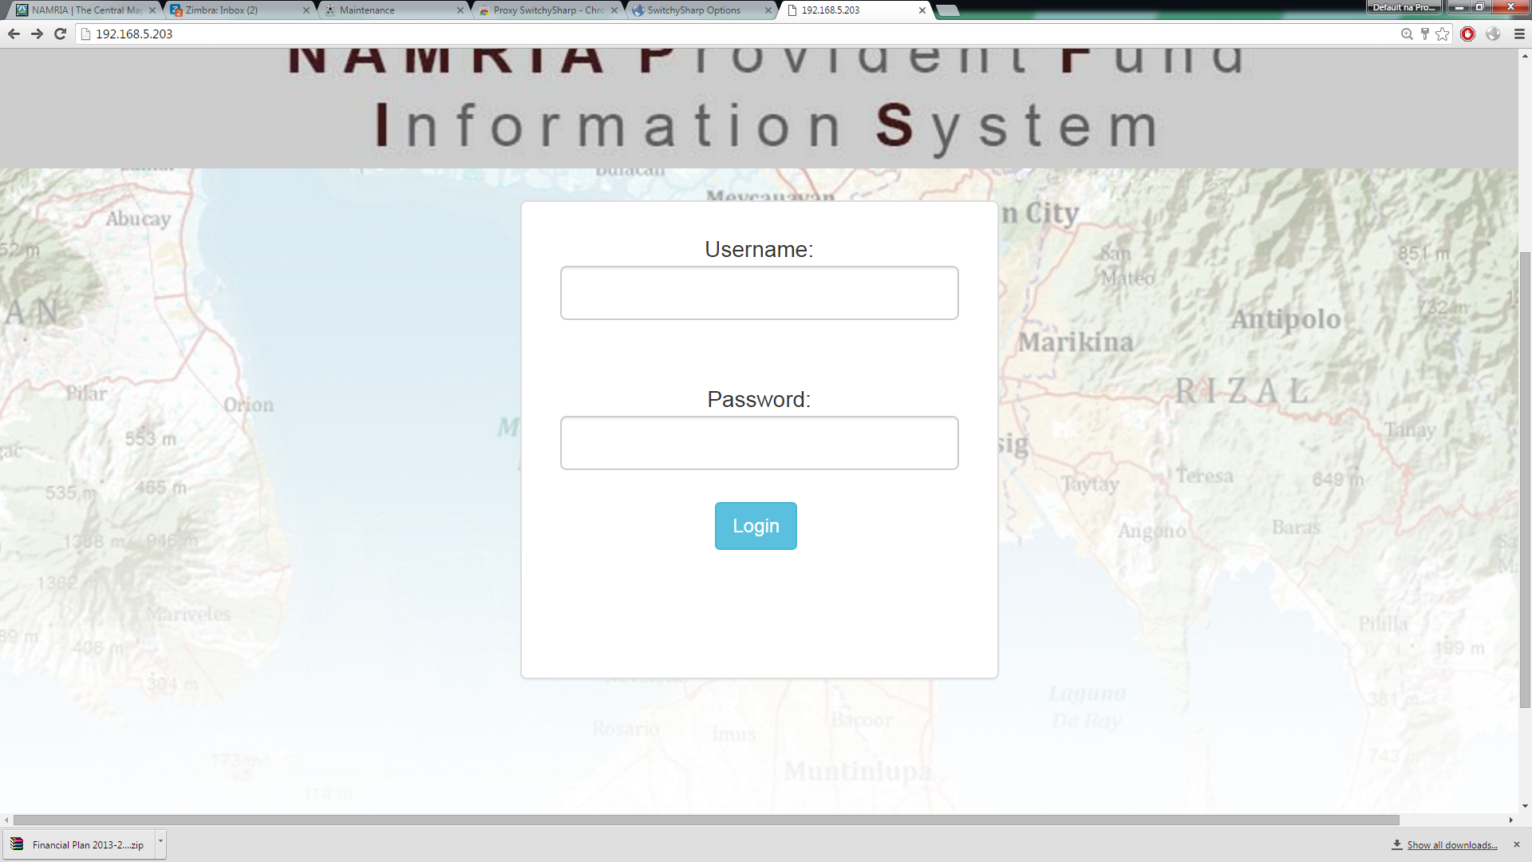  
Figure I. Login Page

**Member Maintenance** – Shows menu to access member related features.

**Loan** **Maintenance** – Shows menu to access loan related features.

**Library** **Maintenance** – Shows menu to access application related features.

**Site** **Navigation/Breadcrumbs** – Shows the current location in the application.

**User** **Name** **and** **Log** **out** **Button** – Shows the logged in User’s Name and Log out button to disconnect to the Application.

# **How to use Loan Management**

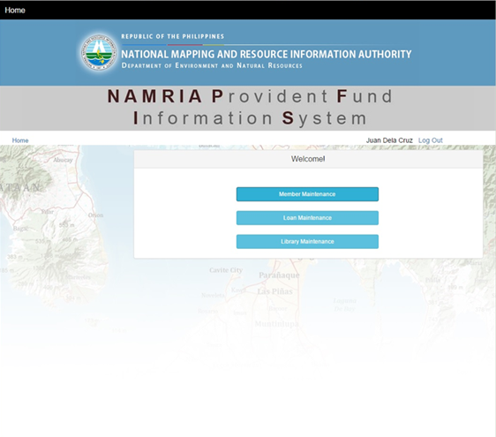

Figure I. Landing Page

1. 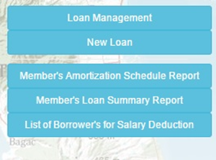Click the Loan Maintenance Button (See Figure I)

**Figure II.** Loan Maintenance Menu

1. Click the Loan Management Button (See Figure II).

This will display the Loan Management Panel (See Figure III).

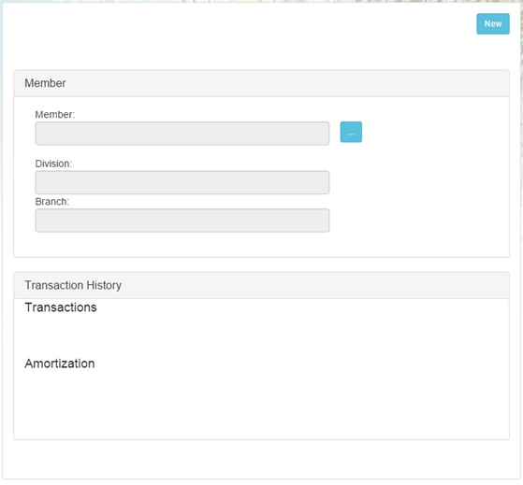

**Figure III.** Loan Management Panel

1. Click the ‘…’ Button to display the Member Search Panel (see Figure IV).

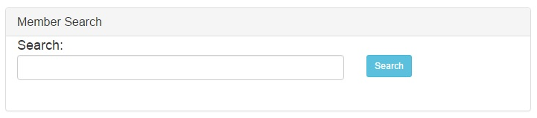

Figure IV. Member Search Panel

1. Type a search keyword. The keyword may be the member’s first name, middle name, last name or the employee Id. Click Search for the application to start with searching.
2. On the Search Result table, click the **Select** **Button** (see Figure V).

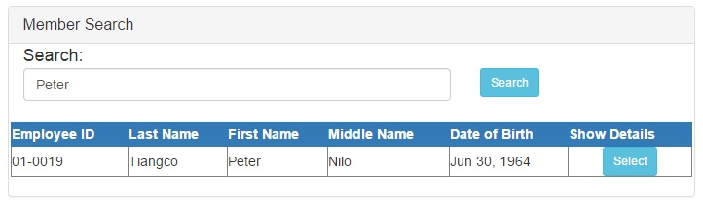

Figure V. Member Search with Search Result(s)

To select the member to load the table of loan transactions (Figure VI).

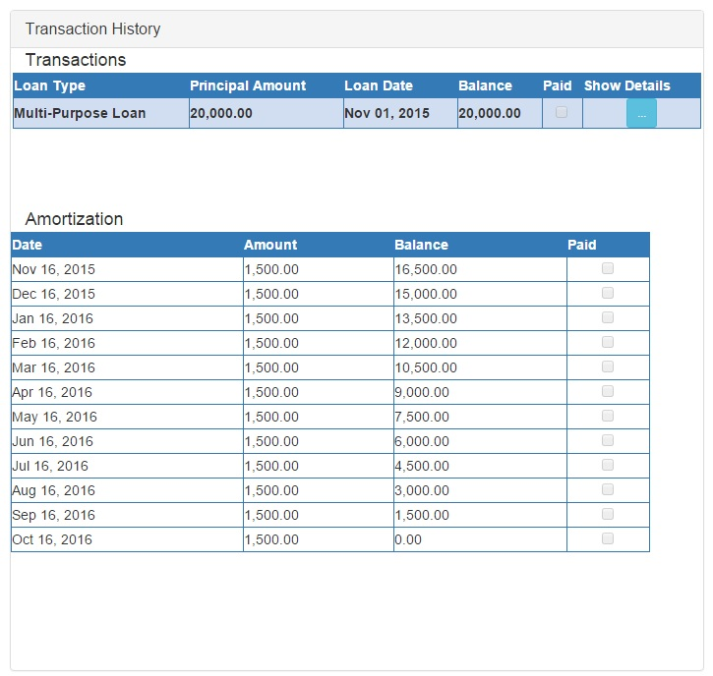

Figure VI. Loan Transaction with the Loan Amortization Schedule.

1. On the Loan Transaction table, select the loan transaction to load the table of amortization schedules (see Figure VI).
2. The user can review the loan transaction information by clicking on the ‘…’ under the show details button to launch a separate page where all the loan transaction information can be viewed (see Figure VI). Sometimes, the page does not immediately show as some browsers blocks popup page. This can be fixed by allowing popups to open.
3. On the Amortization Schedule table, select an amortization schedule and the paid checkbox will enable and tick the checkbox to mark the selected amortization schedule as paid and a message box will appear to notify the user (see Figure VII). The user can also untick the checkbox to mark the selected amortization schedule as unpaid.



Figure VII. Transaction Saved Message Box

# **How to use New Loan**

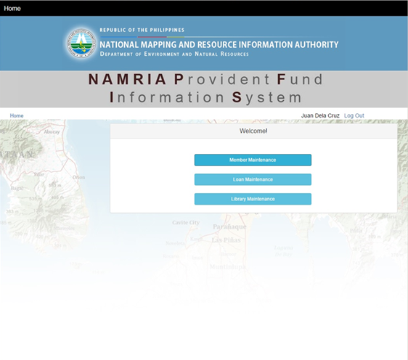

1. Click the Loan Maintenance Button (See Figure I).
2. 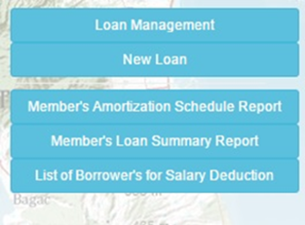Click the New Loan Button (see Figure II).

This will display the New Loan Panel (see Figure VIII).

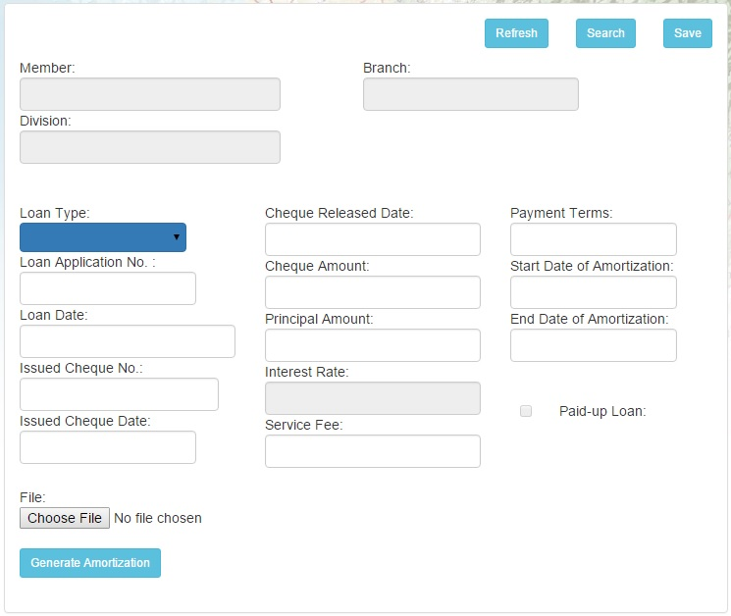

Figure VIII. New Loan Panel

1. Click the Search Button to display the Member Search Panel (see Figure IV).
2. Type a search keyword. The keyword may be the member’s first name, middle name, last name or the employee Id.
3. On the Search Result table, click the Select Button to select the member (see Figure V).
4. Encode the necessary information on the New Loan Panel (see Figure VIII).
5. Click Generate button to create a table or amortization schedules (see Figure IX).

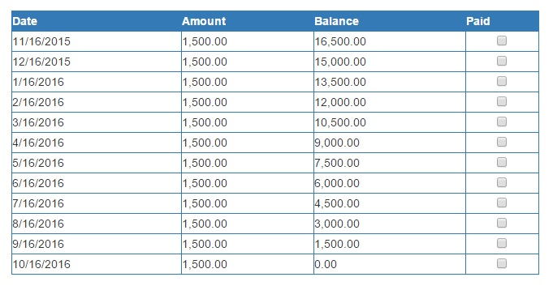

Figure IX. Generated Amortization Schedules

1. Click **Save** button to save. A message box will appear to notify the user that Loan Transaction is created (see Figure VII).

## **How to use Member’s Amortization Schedule Report**

1. Click the Loan Maintenance Button (see Figure I).
2. Click the Member’s Amortization Schedule Report (see Figure II).
3. Type a search keyword. The keyword may be the member’s first name, middle name, last name or the employee Id.
4. On the Search Result table, click the Select Button to select the member (see Figure V).
5. On the Loan Transaction table, Click a row in the Loan Transactions table and the Preview button will appear (see Figure X). Click Preview Button to show a preview page of the report (see Figure XI).

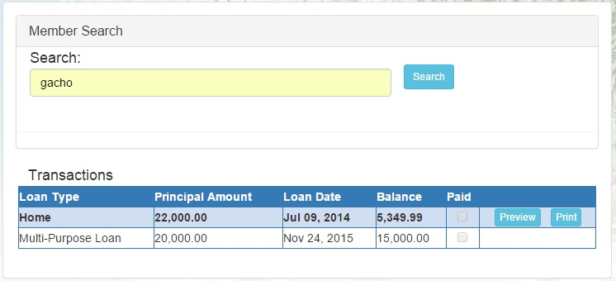

Figure X. Selecting Loan Transaction for preview

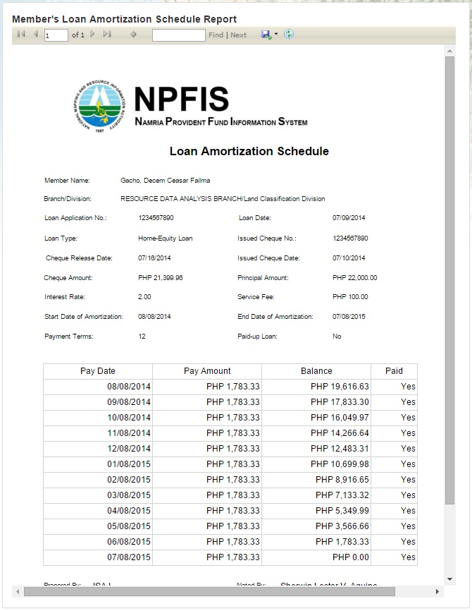

Figure XI. Loan Amortization Schedule Preview Page

1. To print the report, simply click the Save Icon. Please select one of the 3 choices save it in that format. After saving it, click on the saved file then click print.

## **How to use Member’s Loan Summary Report**

1. Click the Loan Maintenance Button (see Figure I).
2. Click the Member’s Loan Summary Report (see Figure II).
3. Click the Report Date textbox. The user can either type the date in this format DD/MM/YYYY or be selected in the date picker (see Figure XII).

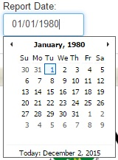

Figure XII. Report Date Textbox with Date Picker

1. Click Preview (see Figure XIII) to reload the page with the correct values in the Preview panel (see Figure XIV).



Figure XIII. Preview Button

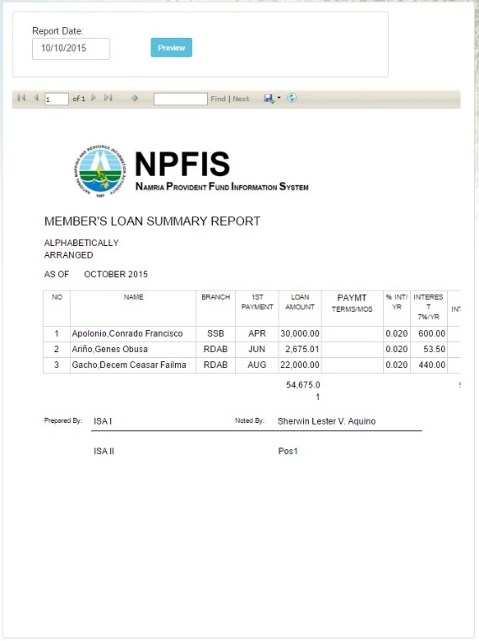

Figure XIV. Member’s Loan Summary Report with Sample Data

1. To print the report, simply click the Save Icon. Please select one of the 3 choices save it in that format. After saving it, click on the saved file then click print.

## **How to use List of Borrower’s for Salary Deduction Report**

1. Click the Loan Maintenance Button (see Figure I).
2. Click the Member’s Loan Summary Report (see Figure II).
3. Click the Report Date textbox. The user can either type the date in this format DD/MM/YYYY or be selected in the date picker (see Figure XII).
4. Click Preview (see Figure XIII) to reload the page with the correct values in the Preview panel (see Figure XV).

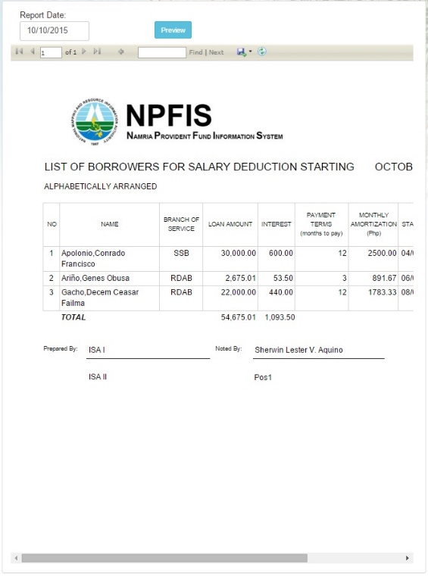

Figure XV. List of Borrower’s for Salary Deduction Report

1. To print the report, simply click the Save Icon. Please select one of the 3 choices save it in that format. After saving it, click on the saved file then click print.

## **How to use Signatory Library**

1. Click the Library Maintenance Button (see Figure I).
2. Click the Signatory Library Button (see Figure XVI). This will redirect the user to the Signatory Library (see Figure XVII).

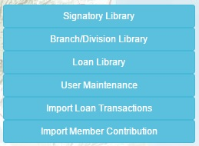

Figure XVI. Library Maintenance

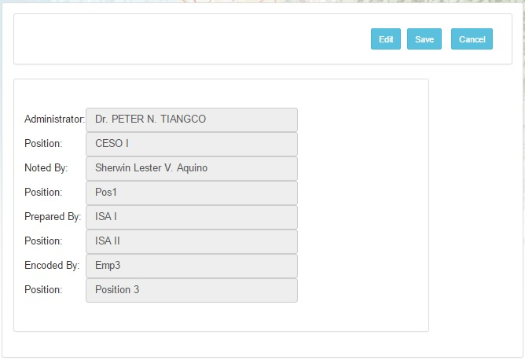

Figure XVII. Signatory Library Panel

1. Click Edit button to edit Signatory fields (see Figure XVII).
2. Encode the necessary information on the Signatory Library Panel (see Figure XIX).
3. Click Save button to save (see Figure XVII). A Confirmation Message (see Figure XVIII) will appear informing the user whether to save the signatory detail or not. Once saved, a message box will be displayed to notify the user that Signatory details has been saved.

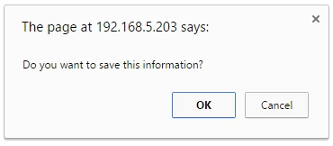

Figure XIX. Save Confirmation Message



Figure XX. Signatory saved message box

## **How to use Branch/Division Library**

### How to Add a Branch

1. Click the New Button (see Figure XX). The Select Branch Panel will be replaced by New Branch Panel (see Figure XXI).



Figure XX. New Button

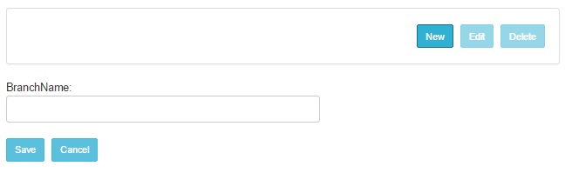

Figure XXI. New Branch Panel

1. Encode the necessary information on the new Branch Panel.
2. Click Save button to save (see Figure XXII). A Confirmation Message (see Figure XXIII) will appear informing the user whether to save the Branch or not. Once saved, a message box (see Figure XXIV) will be displayed to notify the user that Branch Name has been saved.



Figure XXII. Save Button

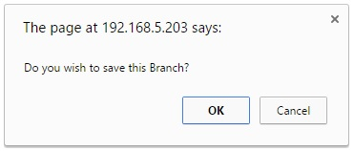

Figure XXIII. Confirm save branch



Figure XXIV. Branch saved message box

### How to Edit a Branch

1. On the Select Branch Panel, Select the Branch to be edited (see Figure XXV).

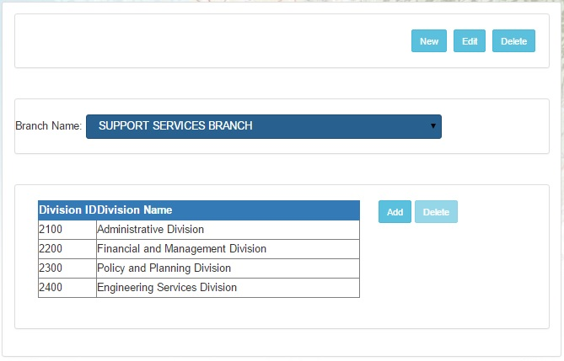

Figure XXV. Selected branch with Divisions

1. Click the Edit Button (see Figure XXVI). The Select Branch Panel will be replaced by Edit Branch Panel with the Branch Name loaded into the Textbox (see Figure XXVII).



Figure XXVI. Edit Button

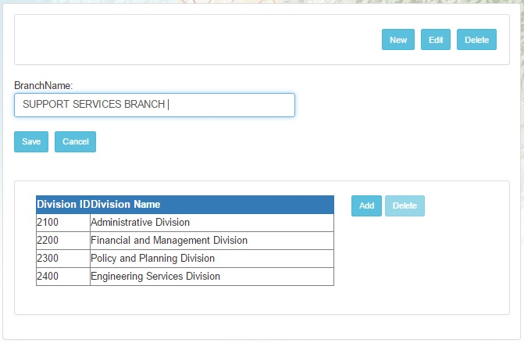

Figure XXVII. Edit Branch Panel with Sample Data

1. Encode the necessary information on the Edit Branch Panel.
2. Click Save button to save (see Figure XXII). A Confirmation Message (see Figure XXIII) will appear informing the user whether to save the branch or not. Once saved, a message box (see Figure XXIV) will be displayed to notify the user that Branch Name has been saved.

### How to Delete a Branch

1. On the Select Branch Panel, Select the Branch to be deleted (see Figure XXV).
2. Click the Delete Button (see Figure XXVIII). A Confirmation Message (see Figure XXIX) will appear informing the user whether to delete the branch detail or not. Once deleted, a message box (see Figure XXX) will be displayed to notify the user that the selected branch has been deleted.



Figure XXVIII. Delete Button

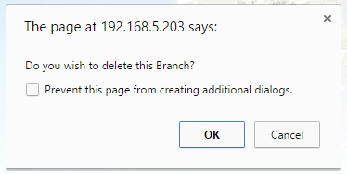

Figure XXIX. Delete branch confirmation button



Figure XXX. Branch delete message box

### How to Add a Division

1. On the Select Panel, Select the Branch to load the table of divisions connected to the selected branch (see Figure XXV).
2. On the Division table, click the Add button. A new row will appear below the Division Table (see Figure XXXI).

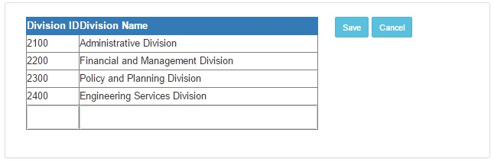

Figure XXXI. Division Table with Sample Data.

1. Encode the necessary information on the row provided.

1. Click Save button to save (See Figure XXXI). A Confirmation Message (see Figure XXXII) will appear informing the user whether to save the Division details or not. Once saved, a message box (see Figure XXXIII) will be displayed to notify the user that Division information has been saved.

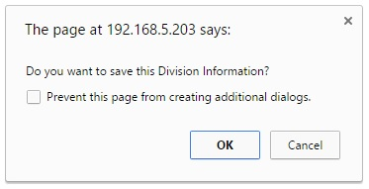

Figure XXXII. Confirm save division



Figure XXXIII. Division saved message box

### How to Delete a Division

1. On the Select Panel, Select the Branch to load the table of divisions connected to the selected branch (see Figure XXXI).
2. On the Division table, click the Delete button (see Figure XXXIV). A Confirmation Message (see Figure XXXV) will appear informing the user whether to delete the Division or not. Once deleted, a message box (see Figure XXXVI) will be displayed to notify the user that the selected division has been deleted.



Figure XXXIV. Delete button

Figure XXXV. Delete confirmation message

Figure XXXVI. Division deleted message box

## **User Maintenance**

### How to add a User

1. Click the Library Management Button (see Figure I).
2. Click the User Maintenance (see Figure XVI). This will redirect the user to the User Maintenance Panel (see Figure XXXVII).

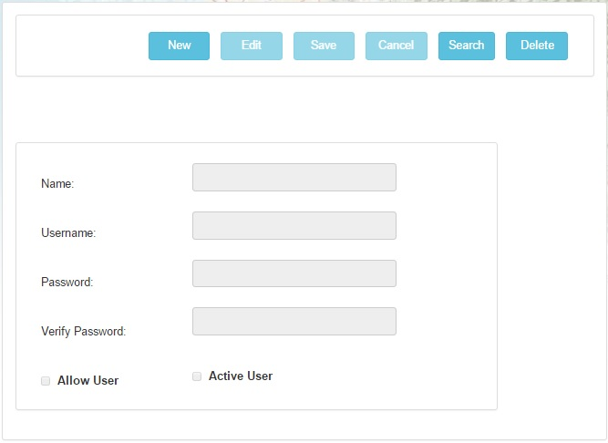

Figure XXXVII. User Maintenance Panel

1. Click the New Button. This will unlock the textboxes.
2. Encode the necessary information in the User Maintenance Panel.
3. Click the Save Button (see Figure XXXVII). A Confirmation Message (see Figure XXXVIII) will appear informing the user whether to save the user or not. Once saved, a message box (see Figure XXXIX) will be displayed to notify the user that the user information has been saved.

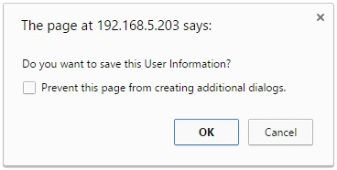

Figure XXXVIII. Confirm User Save



Figure XXXIX. User Saved message box

### How to Edit User Information

1. Click the Library Management Button (see Figure I).

2. Click the User Maintenance (see Figure XVI). This will redirect the user to the User Maintenance Panel (see Figure XXXVII).

1. Click the Search Button (see Figure XXXVII). A User Search Panel will appear (see Figure XXXX).

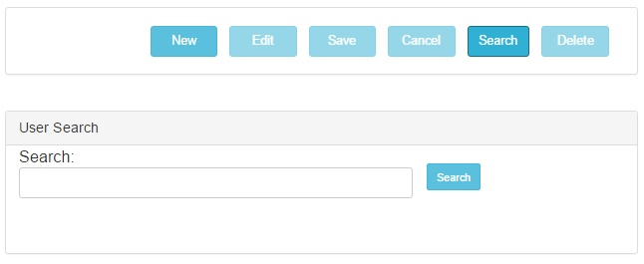

Figure XXXX. User Search Panel

1. Type a Search keyword. The keyword may be the User name or User ID.
2. Click the Select Button (see Figure XXXXI). The User Search Panel will disappear and the user’s information will be loaded into the textboxes for viewing.

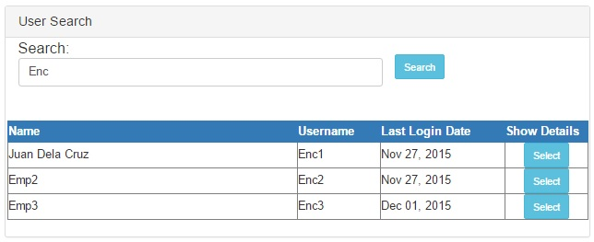

Figure XXXXI. User Search Panel with Sample Data

1. Click the Edit Button (see Figure XXXVII). This will unlock the textboxes.
2. Encode the necessary information in the User Maintenance Panel.
3. Click the Save Button (see Figure XXXVII). A Confirmation Message (see Figure XXXVIII) will appear informing the user whether to save the user or not. Once saved, a message box (see Figure XXXIX) will be displayed to notify the user that the user information has been saved.

### How to Delete a User

1. Click the Library Management Button (see Figure I).

2. Click the User Maintenance (see Figure XVI). This will redirect the user to the User Maintenance Panel (see Figure XXXVII).

3. Click the Search Button (see Figure XXXVII). A User Search Panel will appear (see Figure XXXX).

1. Type a Search keyword. The keyword may be the User name or User ID.
2. Click the Select Button (see Figure XXXXI). The User Search Panel will disappear and the user’s information will be loaded into the textboxes for viewing.
3. Click the Delete Button (see Figure XXXVII) . A Confirmation Message (see Figure XXXXII) will appear informing the user whether to save the user or not. Once saved, a message box (see Figure XXXIII) will be displayed to notify the user that the user information has been saved.

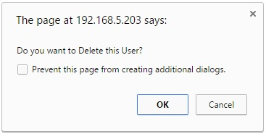

Figure XXXXII. Confirm User Delete



Figure XXXXIII. User Deleted message box

## **How to use Member Maintenance**

* 1. Click the Member Maintenance Button (See Figure 1)
  2. Click the Member Maintenance Button (See Figure 2). This will display the Member Maintenance Panel (See Figure III).

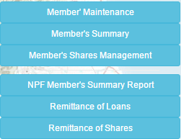

Figure II. Member Maintenance Menu

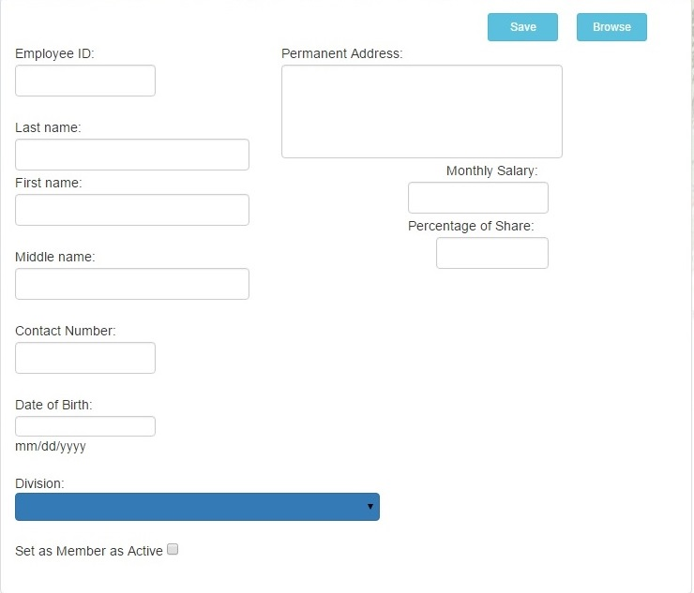

Figure III. Member Maintenance Panel

* 1. Fill in the fields for the New Member in Figure III. Member Maintenance Panel.
  2. Click Save Button if done. (See Figure III)

## **How to use Member Browse**

1. In Member Maintenance click Browse Button (See Figure III).

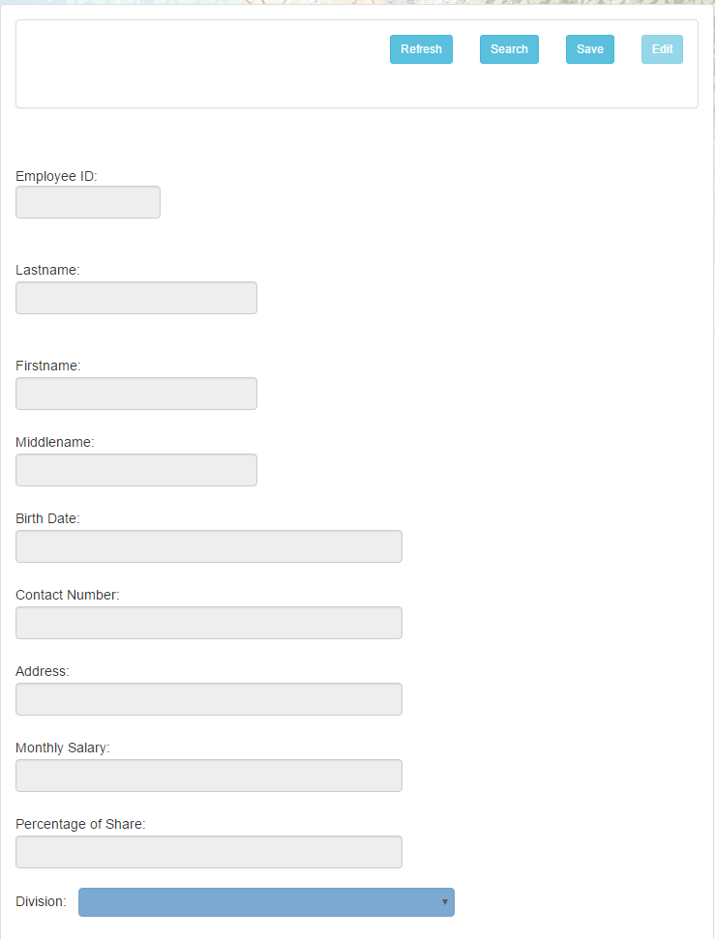

Figure IV. Member Browse Panel

1. Click Search Button to display Member Search Panel (See Figure V).

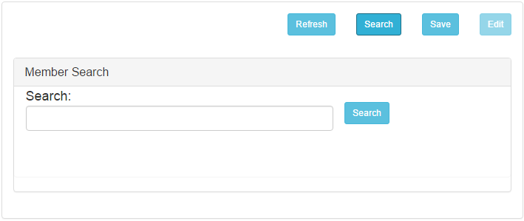

Figure V. Member Search Panel

1. Enter name of Member to search in Member Search Panel and click Search next to the space provided.

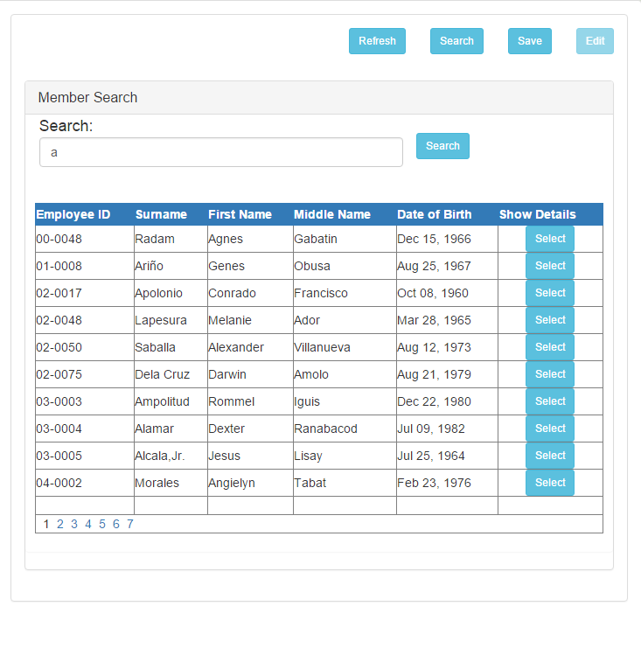

Figure V. Member Browse Search Result

1. Click the Select Button of the correct Member from the search result

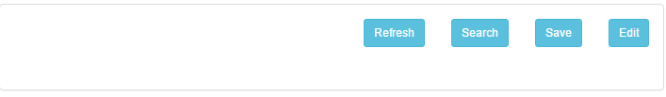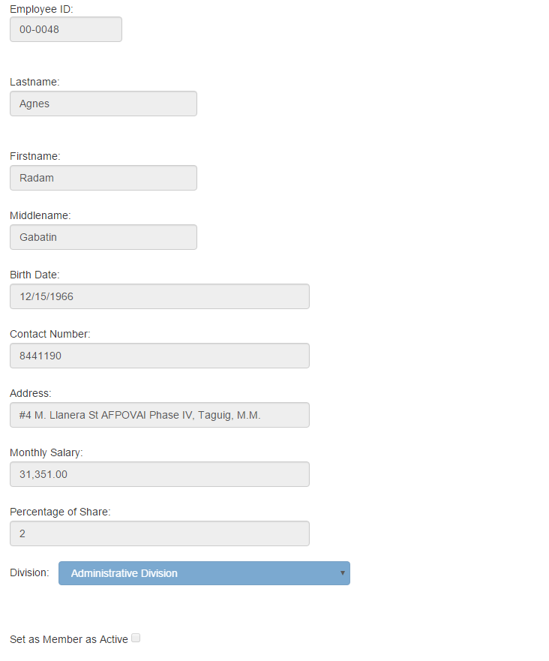

Figure VI. Selected Member

1. To Edit Member Details click Edit Button (see Figure VII).

Figure VII. Member Browse Buttons

1. Member Details will now be editable (Except Employee Number) (See Figure VIII).

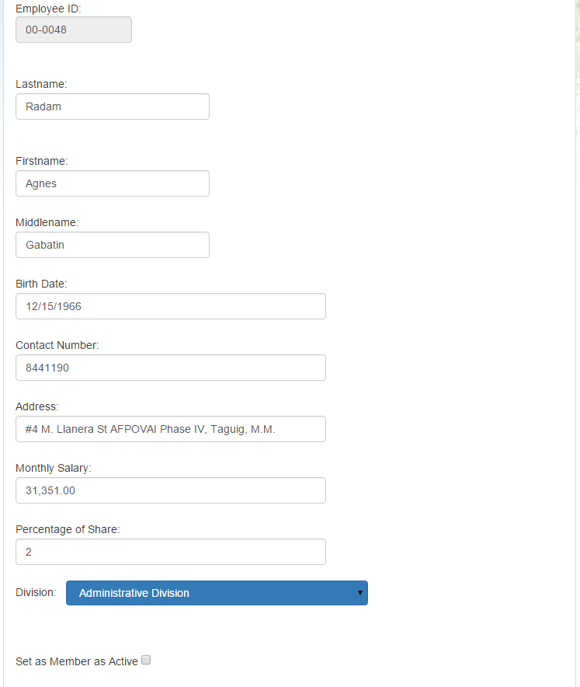

Figure IIX. Editable Details.

1. Click Save when finish editing (See Figure VII). If successful a notification will appear and textboxes will be cleared

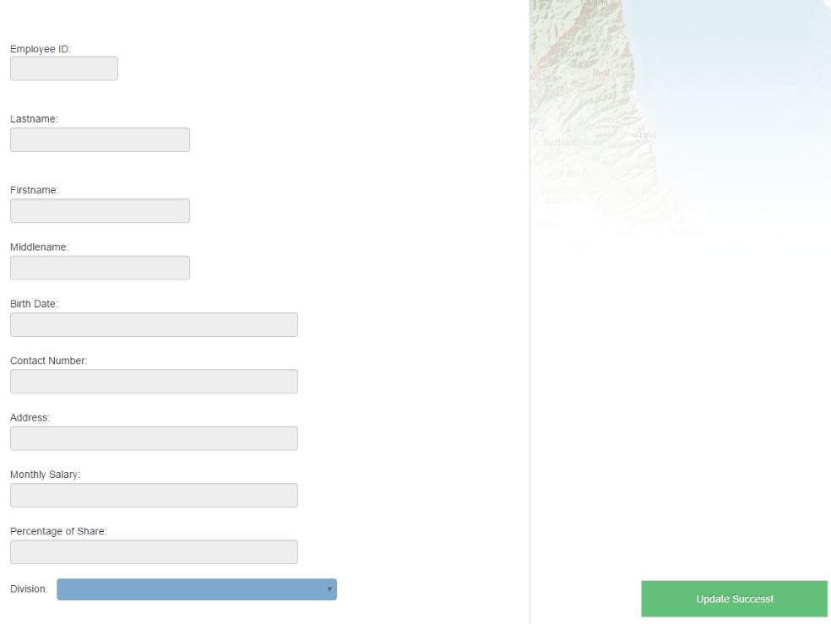

Figure IX. Edit Success

## **How to use Member’s Summary**

1. Click Member’s Summary Button (See Figure II). Member’s Summary Page will display.

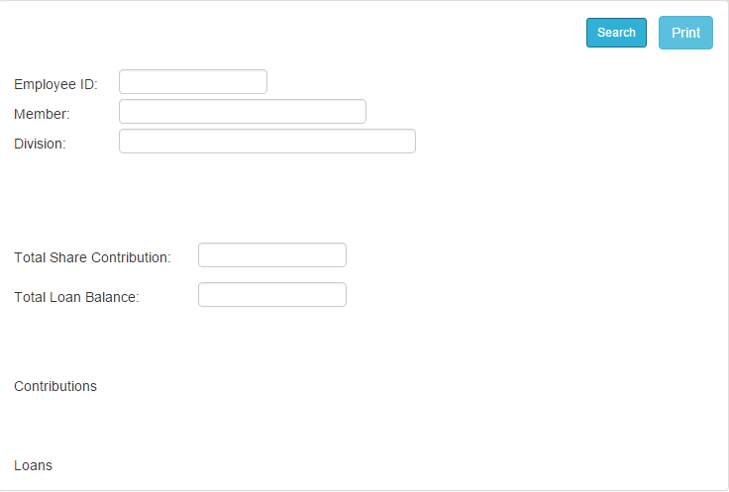

Figure X. Member Summary Page

1. To search Member click Search Button (See Figure X). Search tab will appear (See Figure XI).

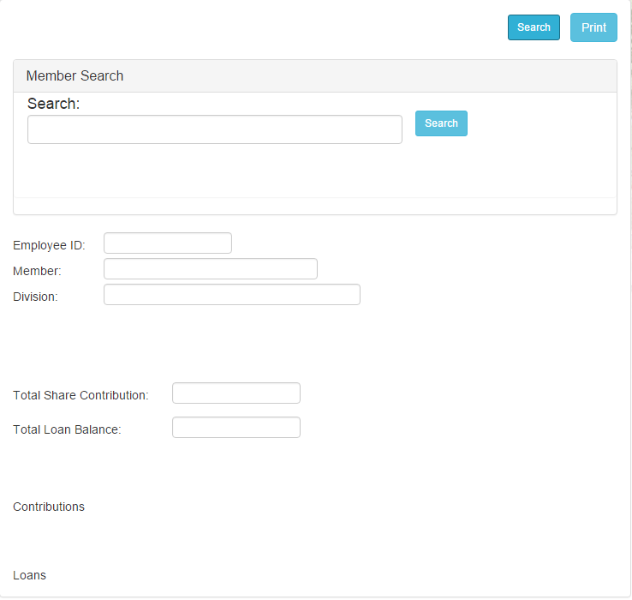

Figure XI. Search tab in Member Summary.

1. 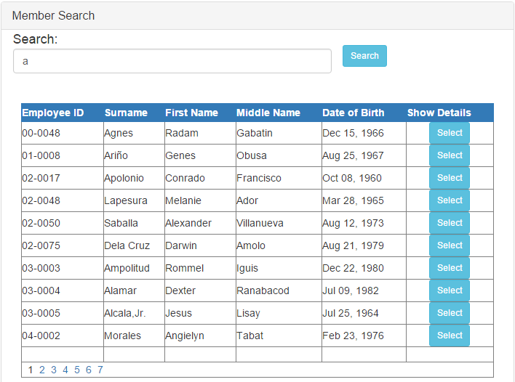Enter Name or Employee number in Search tab and click Search Button next to the space provided. Search Results will appear. (See Figure XII).

Figure XII. Search Results.

1. Click Select right next to the correct Member. Member Summary Info will appear (See Figure XIII).

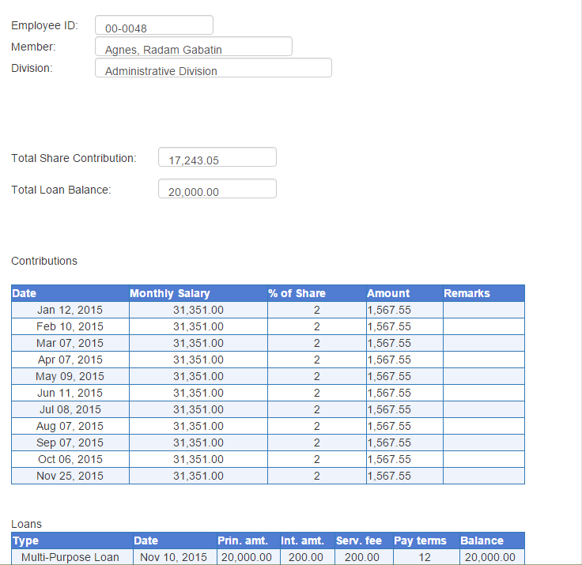

Figure XIII. Member Summary.

## **How to use Member’s Shares Management**

1. Click Member’s Shares Management Button (See Figure II).
2. Member’s Shares Management Page will display.

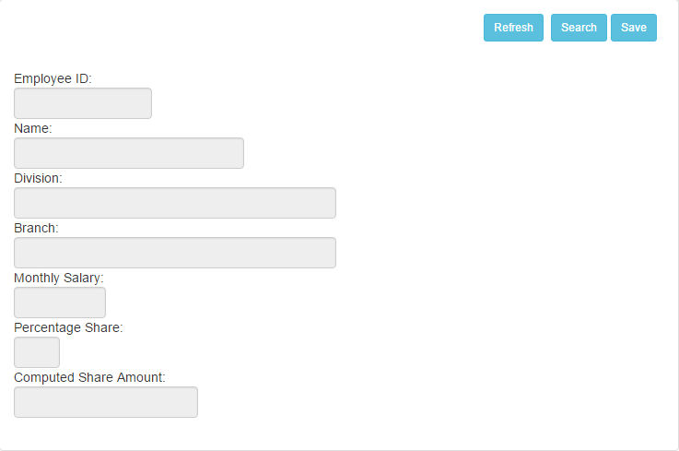

Figure XIV. Member’s Shares Management Page.

1. Click Search Button to Search Member (See Figure XIV).

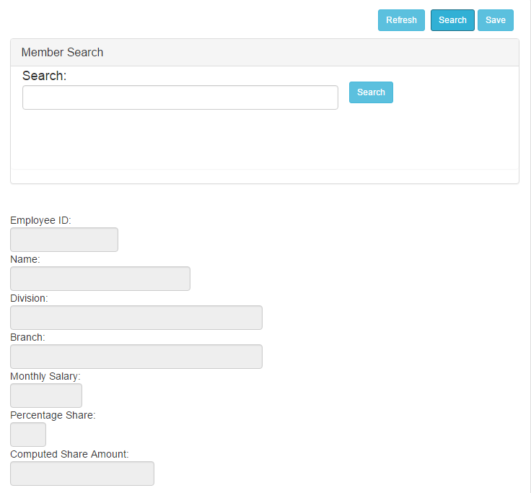

Figure XV. Member Share’s Management Search tab.

1. Enter name or employee number and click Search Button next to the space provided (See Figure XV). Search Results will appear (See figure XVI).

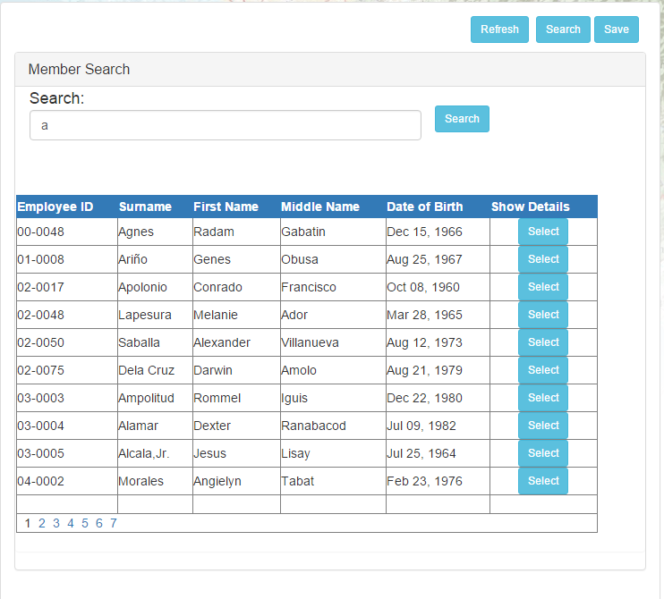

Figure XVI. Member Search result for Member’s Shares Management

1. Click Select next to the correct Member to display details. (See Figure XVII).

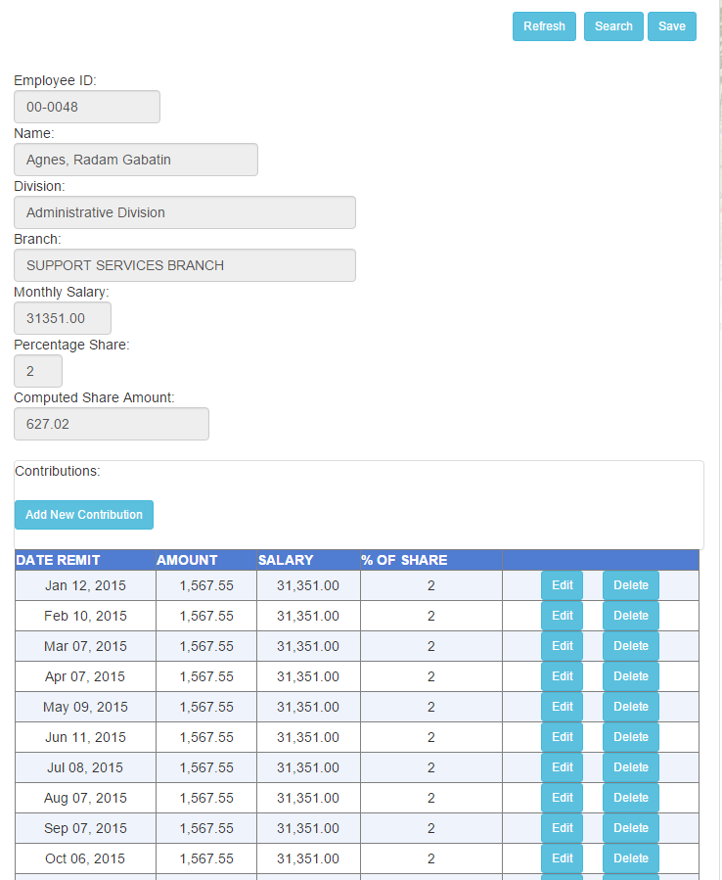

Figure XVII. Member Contribution Grid

1. Click Add New Contribution Button to Add (See figure XVII) to add contribution. Textboxes will appear at the lowest row.

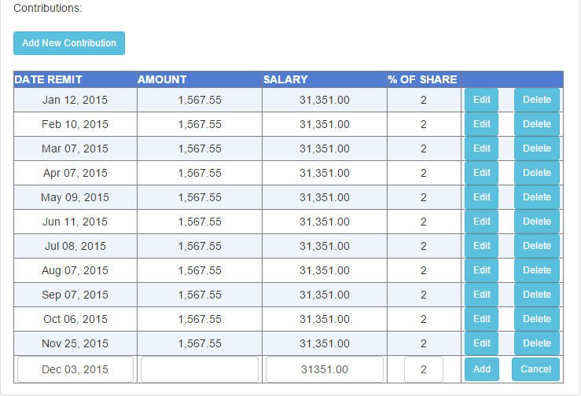

Figure XVIII. Add new contribution

1. Enter the correct Amount and click Add button (See figure XVIII). Click OK button from Confirmation Message. (See figure XIX).

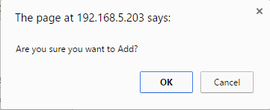

Figure XIX. Add new contribution confirmation message  
.

1. Success notification will appear in the lower right when contribution is successfully added (See Figure XXI).

C:\Users\robin\Pictures\NPFIS\addsuccess.png

Figure XXII. Success notification Add new contribution.

1. Click Edit button to edit a specific contribution (See Figure XVII). Amount Textbox will be available for Edit for that contribution (See Figure XXII).

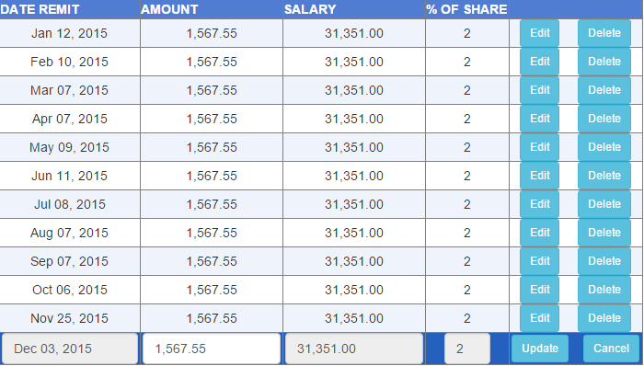

Figure XXII. Edit Contribution.

1. Click Update button (See Figure XXII) to update specific contribution. A notification will appear confirming it successful. (See Figure XXIII).

C:\Users\robin\Pictures\NPFIS\editsuccess.png

Figure XXIII. Edit Contribution Success

1. Click Cancel button to cancel current editing of contribution. (See Figure XXII).
2. Click Delete button to delete a specific contribution (See Figure XVII). Click OK from the confirmation message to continue deleting (See Figure XXIV).

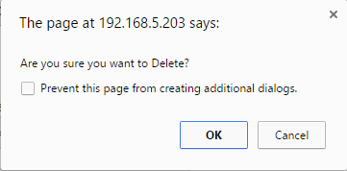

Figure XXIV. Delete contribution Message.

## **How to use NPF Member’s Summary Report**

1. Click NPF Member’s Summary Button (See Figure II.)
2. NPF Member’s Summary Page will display (See Figure XXV).

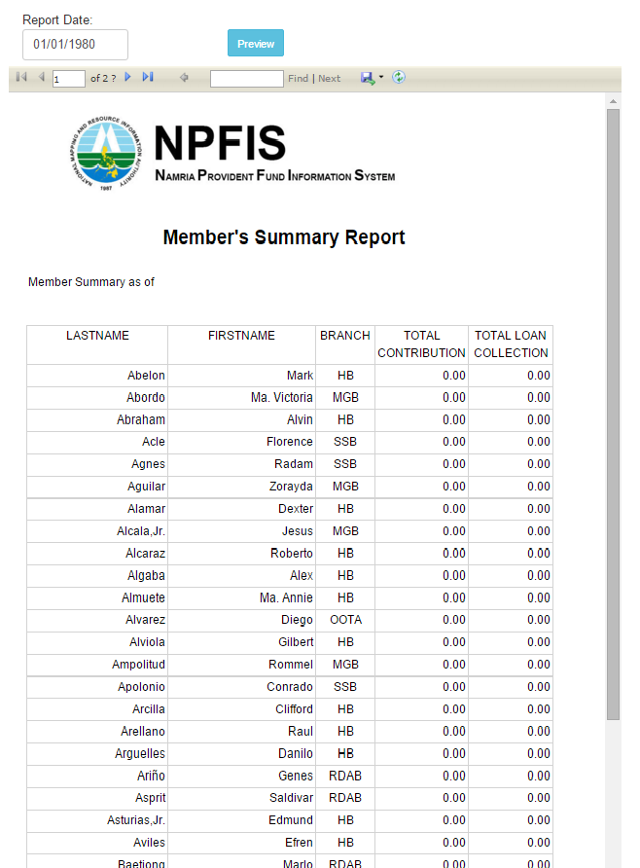

Figure XXV. Member’s Summary Report

1. Click textbox below Report Date to select a date to Preview. (See Figure XXVI).

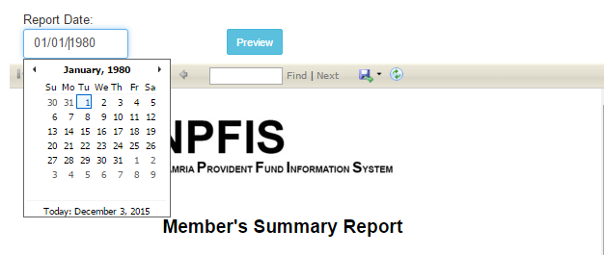

Figure XXV. Select Report Date.

1. Click Preview Button to Preview Report Summary of Selected Date. (See Figure XXV).

## **How to use Remittance of Loans**

1. Click Remittance of Loans Button (See Figure II).
2. Remittance of Loans Page will Display (See Figure XXVII).

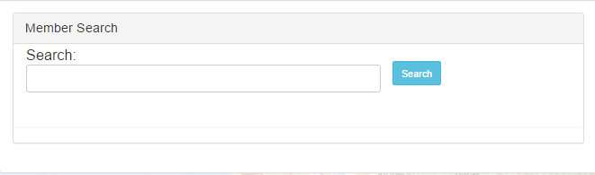

Figure XXVII. Remittance of Loans Search tab.

1. Enter name or employee number and click Search Button next to the space provided (See Figure XXVVII). Click Search, results will appear.

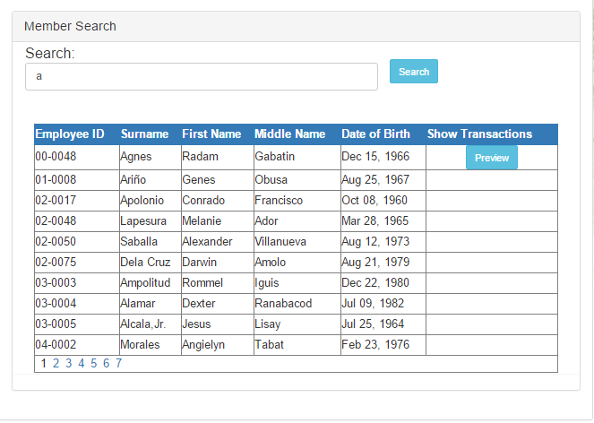

Figure XXIIX. Search Results.

1. Click Preview button to Preview Member’s Remittance of Loans. (See Figure XXIIX)

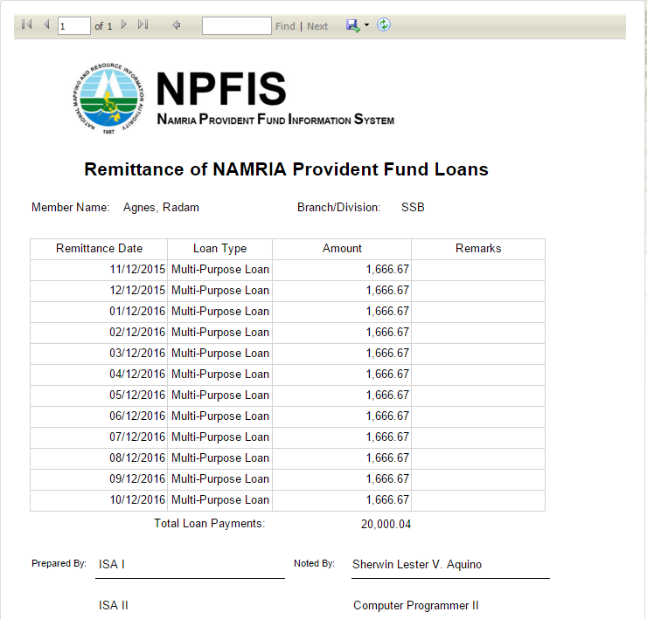

Figure XXIX. Remittance of Loans Preview.

## **How to use Remittance of Shares**

1. Click Remittance of Shares button (See Figure II).
2. Remittance of Loans Page will Display (See Figure XXX).



Figure XXX. Remittance of Shares Search tab.

1. Enter name or employee number and click Search Button next to the space provided (See Figure XXXI). Click Search, results will appear.



Figure XXXII. Search Result.

1. Click Preview button to Preview Member’s Remittance of Shares. (See Figure XXXII)

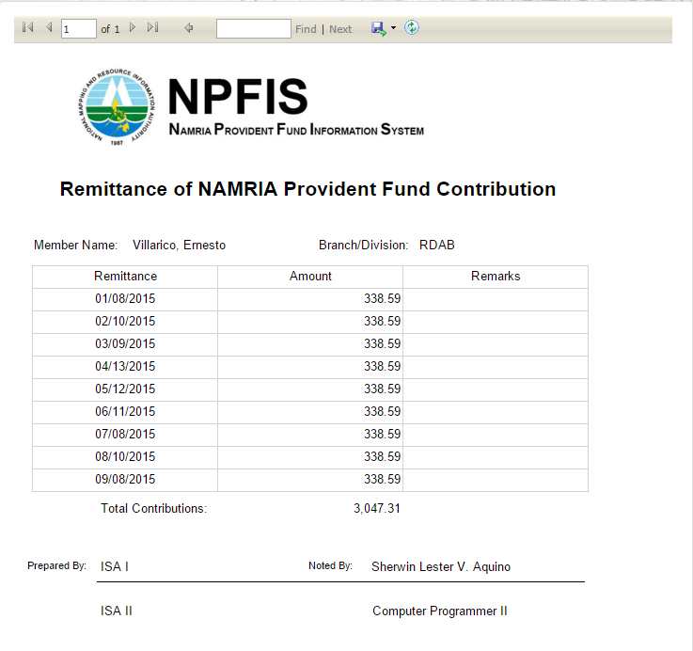

Figure XXXIII. Remittance of Shares Preview

## **How to use Loan Library**

1. Click Library Maintenance button (See Figure I).
2. Library Maintenance Menu will appear. (See Figure XXXIV)

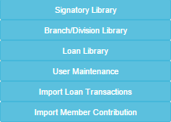

Figure XXXIV. Library Maintenance Manu

1. Click Loan Library button. (See Figure XXXIV).

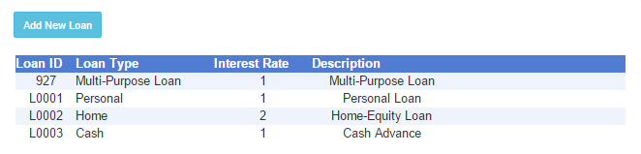

Figure XXXIV. Loan Library.

1. Click Add New Loan button to add a Loan (See Figure XXXIV). Textboxes will appear to be filled (See Figure XXXV),

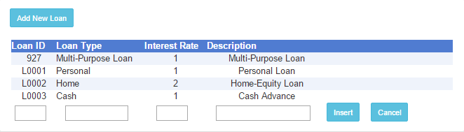

Figure XXXV. Add new Loan.

1. Click Insert to add new Loan. (See Figure XXXV). Click OK button from Confirmation Message to save new Loan (See Figure XXXVI).

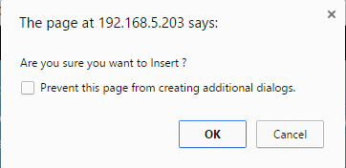

Figure XXXVI. Click OK button.

1. Success Notification will appear if Successful. (See Figure XXXVII).

C:\Users\robin\Pictures\NPFIS\NEWLOANSUCCESS.png

Figure XXXVII. New Loan Saved.

1. Click any Loan from Loan Library to Edit Loan (See Figure XXXIV). Edit button will appear (See Figure XXXVIII).

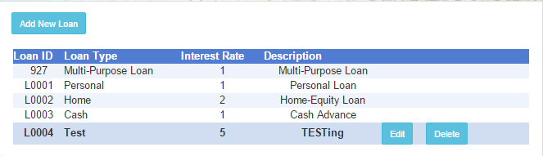

Figure XXXVIII. Edit Loan

1. Click Edit button to Edit Loan (See Figure XXXVIII). Details will now be editable (See Figure XXXIX).

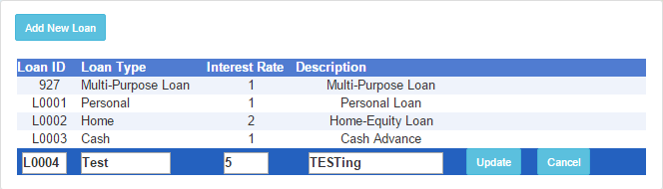

Figure XXXIX. Editable Loan.

1. Click Update button after editing (See Figure XXXIX). Click OK button from confirmation message (See Figure XL).

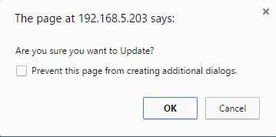

Figure XL. Confirmation Message Edit Loan.

1. Success Notification and update on Loan will be saved (See Figure XLI).

C:\Users\robin\Pictures\NPFIS\EDITLOANERS.png

Figure XLI. Edit Loan Saved.

1. Click Cancel button to cancel Edit Loan (See Figure XXXIX).
2. Click Delete button to Delete Loan (See Figure XXXVII). Click OK button from Confirmation Message to confirm Delete Loan. (See Figure XLII).

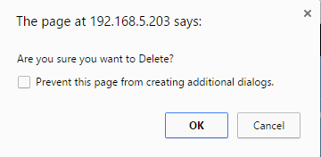

Figure XLII. Delete Loan Confirmation

1. Notification will appear if Loan is successfully deleted. (See Figure XLIII).

C:\Users\robin\Pictures\NPFIS\DELETELOANSUCCESS.png

Figure XLII. Successfully Deleted Loan Notification.

## **Using Import Loan Transactions**

1. Click Import Loan Transactions button (See Figure II).
2. Import Loan Transactions Page will display (See Figure XLIV).

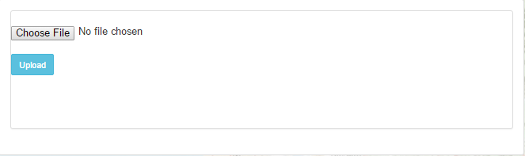

Figure XLIV. Import Loan Transactions Page.

1. Click Choose File button and navigate to the folder where the excel file is located and click Open button to select file. (See Figure XLV).

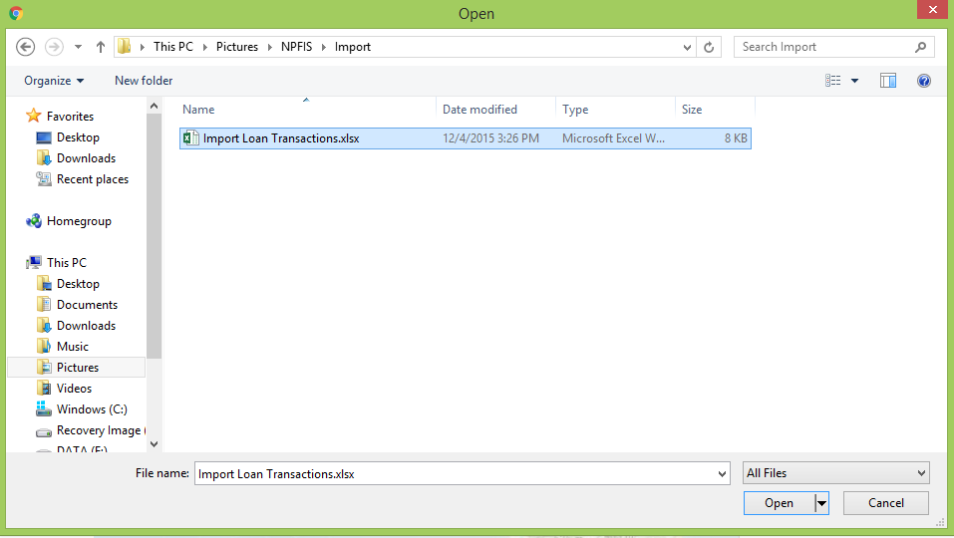

Figure XLV. Select file to Import

1. Click Upload button to upload file. (See Figure XLIV).

## **Using Import Member Contribution**

1. Click Import Member Contribution button (see Figure II).
2. Import Member Contribution Page will display (See Figure XLVI).



Figure XLVI. Select File to Import

1. Click Choose File button and navigate to the folder where the excel file is located and click Open button to select file. (XLVII).

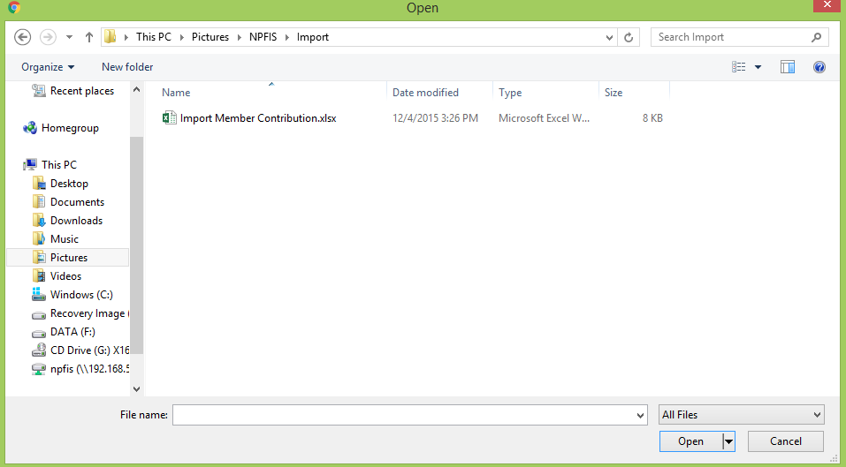

Figure XLVII. Select File to Import

1. Click Upload button to upload file. (See Figure XLVI).